THREE ADDRESS CODE (TAC) GENERATION
C Programming Lab Record

Student Details
Name | Sama Vaishnavi
Register Number | 192372117
Course / Subject | C Programming – Three Address Code

Aim
To write a C program that generates Three Address Code (TAC) for an arithmetic expression, while respecting operator precedence and parentheses.

Program
#include <stdio.h>
#include <stdlib.h>
#include <ctype.h>
#include <string.h>
#define MAX 100
char opStack[MAX];
int opTop = -1;
char *valStack[MAX];
int valTop = -1;
int tempCount = 1;
void pushOp(char ch) {
if (opTop < MAX - 1)
opStack[++opTop] = ch;
}
char popOp() {
if (opTop >= 0)
return opStack[opTop--];
return '\0';
}
char peekOp() {
if (opTop >= 0)
return opStack[opTop];
return '\0';
}
void pushVal(const char *val) {
if (valTop < MAX - 1) {
valStack[++valTop] = malloc(strlen(val) + 1);
if (valStack[valTop] != NULL)
strcpy(valStack[valTop], val);
else
valTop--;
}
}
char *popVal() {
if (valTop >= 0)
return valStack[valTop--];
return NULL;
}
int precedence(char op) {
if (op == '+' || op == '-')
return 1;
if (op == '*' || op == '/')
return 2;
return 0;
}
void processOperator() {
if (valTop < 1 || opTop < 0)
return;
char op = popOp();
char *right = popVal();
char *left = popVal();
char temp[20];
snprintf(temp, sizeof(temp), "t%d", tempCount++);
printf("%s = %s %c %s\n", temp, left, op, right);
pushVal(temp);
free(left);
free(right);
}
void generateTAC(char expr[]) {
int i = 0;
char target[MAX] = "";
int targetIdx = 0;
opTop = -1;
valTop = -1;
tempCount = 1;
/* Extract the target variable */
while (expr[i] != '=' && expr[i] != '\0') {
if (!isspace((unsigned char)expr[i])) {
if (targetIdx < MAX - 1)
target[targetIdx++] = expr[i];
}
i++;
}
target[targetIdx] = '\0';
if (expr[i] == '=')
i++;
else {
i = 0;
target[0] = '\0';
}
printf("\nThree Address Code (TAC):\n");
printf("-------------------------\n");
while (expr[i] != '\0') {
if (isspace((unsigned char)expr[i])) {
i++;
}
else if (isalnum((unsigned char)expr[i])) {
char operand[MAX];
int k = 0;
while (isalnum((unsigned char)expr[i])) {
if (k < MAX - 1)
operand[k++] = expr[i];
i++;
}
operand[k] = '\0';
pushVal(operand);
}
else if (expr[i] == '(') {
pushOp(expr[i++]);
}
else if (expr[i] == ')') {
while (opTop >= 0 && peekOp() != '(')
processOperator();
if (opTop >= 0)
popOp();
i++;
}
else if (strchr("+-*/", expr[i]) != NULL) {
while (opTop >= 0 && peekOp() != '(' &&
precedence(peekOp()) >= precedence(expr[i])) {
processOperator();
}
pushOp(expr[i++]);
}
else {
i++;
}
}
while (opTop >= 0) {
if (peekOp() == '(') {
popOp();
continue;
}
processOperator();
}
char *finalRes = popVal();
if (target[0] != '\0' && finalRes != NULL)
printf("%s = %s\n", target, finalRes);
if (finalRes != NULL)
free(finalRes);
while (valTop >= 0)
free(popVal());
}
int main() {
char expr[MAX] = "a = b + c * d";
printf("Input Expression: %s\n", expr);
generateTAC(expr);
return 0;
}

Output Screenshot
The following screenshot shows the program output in OnlineGDB.
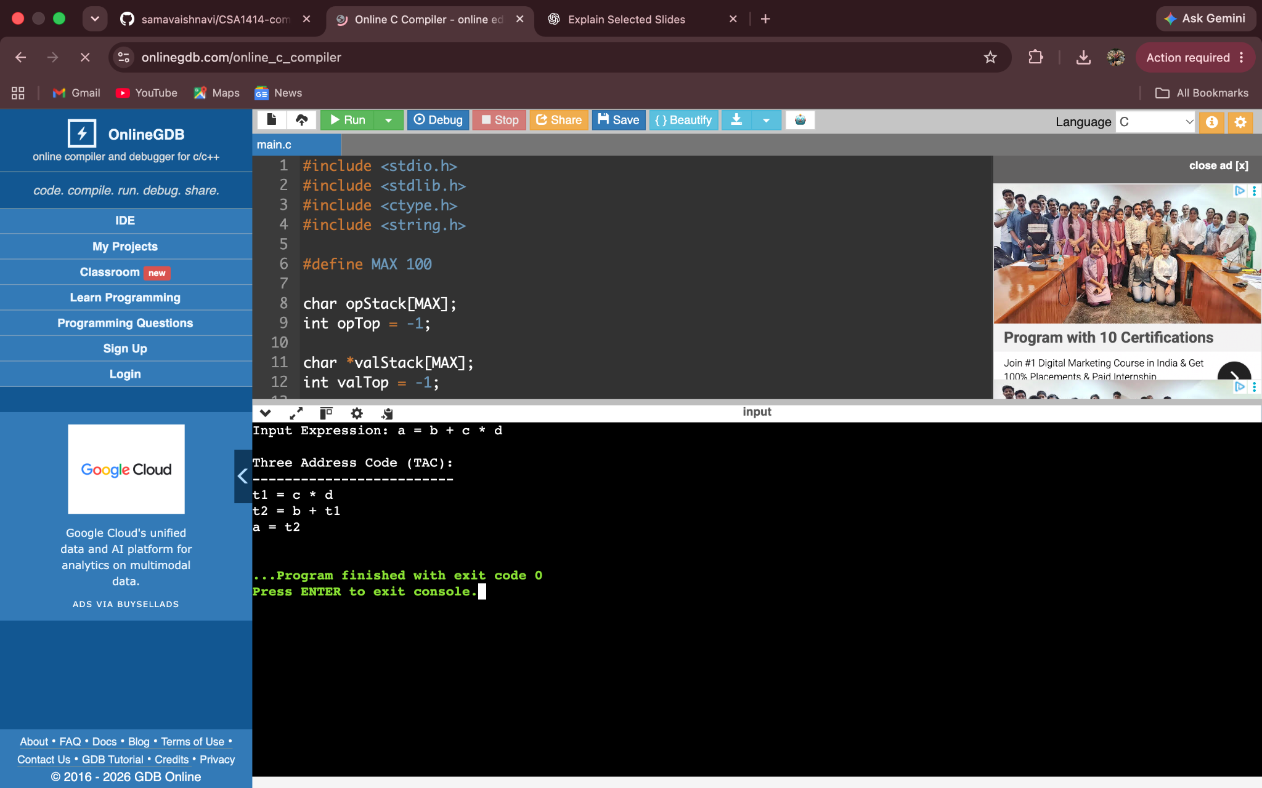

Expected Output
Input Expression: a = b + c * d
Three Address Code (TAC):
-------------------------
t1 = c * d
t2 = b + t1
a = t2

Result
The C program successfully generates Three Address Code for the expression a = b + c * d. Multiplication is performed before addition, and the final result is assigned to a.

